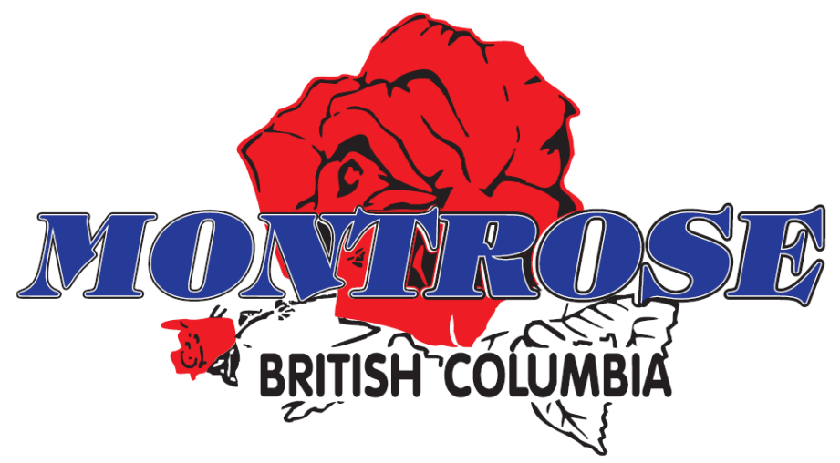

VILLAGE OF MONTROSE

2018 Annual Report of Water Monitoring

June 2018

PO BOX 510
MONTROSE, BC V0G 1P0
Phone :(250) 367-7234 - Fax :(250) 367-7288
E-mail: admin@montrose.ca
Website: www.montrose.ca

Table of Contents

Page

- Introduction 3

2.0 Water System Overview 4
  - Service Area 4
  - Source 4
  - Treatment 5
  - Storage 6
  - Distribution System 6
  - Controls and Communications 6

3.0 Water System Maintenance 7
  - Wells Maintenance 7
  - Reservoirs Maintenance 7
  - Distribution System Maintenance 7
3.3.1 Valve Inspection 7
    - Watermain Flushing and Hydrant Maintenance 8
    - Watermain Breaks 8

4.0 Water System Operator Training Program 9

5.0 Monitoring and Testing Program 10
5.1 Parameters 10
5.2 Results 11

6.0 Annual Consumption Records 13

7.0 Water Conservation 14

8.0 Water Issues in 2017 15

9.0 2017 Capital Works and Projected 2018 Capital Works 16

10.0 Emergency Response and Contingency Plan 18

11.0 Conclusion 19

APPENDIX

Appendix 1: Montrose Water Service Area
Appendix 2: 2018 Drinking Water Bacteriology Summary
Appendix 3: 2018 Chlorine Residual Monitoring Summary
Appendix 4: Emergency Response Plan (Policies # 5600 and #7130)

1.0 Introduction

This report has been produced to meet the requirement for water suppliers to produce an annual report on water quality as per Section 15 of the Drinking Water Protection Act and Section 11(b) of the Drinking Water Protection Regulation.

The annual report covers the period from January 1, 2018 to December 31, 2018 and uses data that is regularly obtained by the Village of Montrose to highlight water quality issues and to discuss the monitoring results of the Village’s water system.

This report aims to convey information to residents regarding the overall operation of the municipal water system and describe the Village’s approach to the operation and maintenance of the water system.

For more detailed information on drinking water health effects, the Village of Montrose recommends the following web sites:

Interior Health Authority
http://www.interiorhealth.ca/YourEnvironment/DrinkingWater/Pages/default.aspx

Health Canada:
http://www.hc-sc.gc.ca/ewh-semt/water-eau/drink-potab/index-eng.php

World Health Organization:
http://www.who.int/water_sanitation_health/dwq/en/

2.0 Water System Overview

The Village of Montrose was incorporated in 1956 and is home to approximately 996 residents. It serves predominantly as a bedroom community to the City of Trail and is located within the Beaver Valley, east of the City of Trail and west of the Village of Fruitvale.

The Village of Montrose is currently classified as a Level II water distribution system. It obtains its domestic water supply from two wells that lay outside the Village boundaries, near the confluence of Beaver Creek and the Columbia River. This source is the most reliable and economical water supply for the Village. Water drawn from the two wells is chlorinated and pumped up to two reservoirs located within the Village, which gravity feed the distribution system. In times of peak demand, some residents receive water directly from the wells.

In February of 2011, upon IHA recommendation, the Village was placed on a Boil Water Notice. The notice was issued due to routine testing showing a persistent low total coliform presence. The Village was still operating under this notice until June 27, 2013 upon completion of a major Gas Tax funded project which provided the Village with a new well, chlorine treatment facility and back-up power generator.

2.1 Service Area
The current water system supplies domestic water to both residents and businesses located within Village boundaries (Appendix 1). In addition, it acts as the only source of fire protection to the Village. It also acts as a backup system to the Beaver Falls Waterworks District, which supplies water to some 500 residents of the Beaver Valley (the area that lies between the Village of Montrose and Village of Fruitvale).

  - Source
As stated above, the Village currently has two production wells located at the confluence of the Beaver Creek and Columbia River. Both wells draw from an unconfined groundwater source.

Well #1 was constructed in 1961 and provided for an estimated safe yield of 47.3 L/s. In 1998, Kala Groundwater Consulting Ltd. was contacted to re-evaluate the well. Upon completion of their investigation, Well #1 was found to suffer from excessive drawdown, and as a result, the well’s safe yield was reassessed to approximately 28.4 L/s. A (2009) assessment of the well references Kala’s safe rate of 28.4 L/s and notes that the well efficiency is declining over time.

Well #2 was constructed in 1981 and provided for an estimated safe yield of 20.8 L/s. Again, in 1998, Kala Groundwater determined that Well #2 could safely be continuously pumped at 21 L/s. At the typical safe design rate of operating for eighteen hours per day, Well #2 can provide the Village with approximately 1,361 m³/day. Well #2 has had issues with ground subsidence since the initial development which has caused settlement of the pumphouse building. Due to this settlement, this well has been capped and abandoned upon completion of Well #3 which was commissioned as part of a major project to disinfect the Villages’ water supply. This well could be used in an emergency
situation and will remain capped for this purpose.

Specifics | Well #1 |  | Well #2 |  | Well #3
 | Original | Current | Original | Current | Original
1. Year Drilled | 1961 |  | 1981 |  | 2013
2. Total Depth (m) | 38.1 |  | 36 |  | 34.7
3. Diameter (mm) | 406 |  | 406 |  | 305
4. Length of Screen (m) | 9.1 |  | 10.9 |  | 10.4
5. Depth to top of Screen (m) | 29 |  | 25 |  | 24.4
6. Safe Yield (L/s) | 47.3 | 28.4 | 20.8 | 21 | 20.5

In emergency conditions, the Village of Montrose’s water supply is supplemented by the neighbouring Beaver Falls Water Works District system. As the Beaver Falls water system is not chlorinated, the Village issues Boil Water advisories if and/or when this activity occurs.

  - Treatment

2013 saw completion of a $1.5M supply and treatment project funded almost entirely through the federal Gas Tax Strategic Initiatives program. This project included construction of a chlorine room, a baffled 90m³ chlorine contact chamber, electrical and controls room and a mechanical/pump room.

Chlorine is injected at the Water Treatment Plant at a rate of 0.75 – 1.0 mg/l with the majority of the distribution system  seeing concentrations of 0.5 – 0.7mg/l. The injection rates fluctuate during the year with the minimum requirement of 0.2 mg/l residual at distribution system extremities used as a control. There are many challenges in maintaining these  limits and dead-end main lines, dual pressure zones, water use and temperatures all affect the required chlorine residual. | 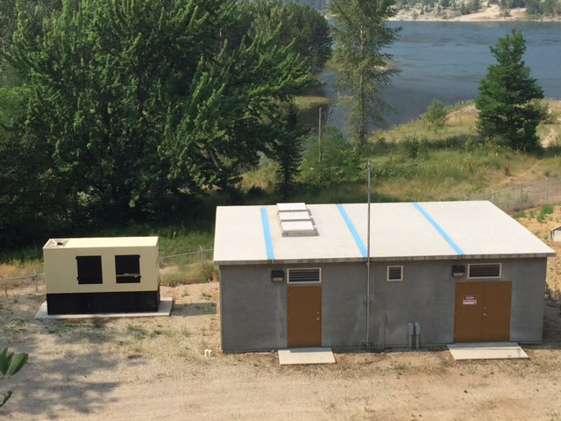
The PW department monitors and records residual levels at various locations within the Village generally three times per week. These levels assist the crew in determining the adjustments to the injection rate to maintain the limits in the water distribution system.

A summary of the chlorine concentration monitoring program is found in Appendix 3.
  - Storage
The Village of Montrose has two reservoirs that store water pumped from the water source.
Reservoir #1 (lower) was constructed in 1959. It is an elevated steel-finished tank consisting of one cell and has a storage capacity of 455m³. Its full water level elevation is approximately 637 metres.

Reservoir #2 (upper) was constructed in 1979. It is also an elevated steel-finished tank consisting of one cell and has a storage capacity of 909m³. Its full water level elevation is approximately 689 metres.

2.5 Distribution System
The Village’s distribution system is segregated into 2 different pressure zones. Reservoir #2 services the highest-pressure zone, which encompasses the northeast portion of the Village, namely most of 12th Avenue, upper 7th Street and the Golden Acres subdivision properties. Reservoir #1 services the lower pressure zone, which encompasses the rest of the Village.

In total, the Village of Montrose has approximately thirteen (13) kilometers of water main within the Villages boundaries, comprised of mainly asbestos concrete (approximately 90%), ductile iron (5%), and polyvinyl chloride or PVC (5%) pipes. Sizes range from 50 mm to 250 mm in diameter. As well, the Village’s has numerous standpipes, and forty-one (41) fire hydrants for fire protection.

The Village of Montrose distribution system also currently has two connection points with the Beaver Falls Waterworks District distribution system. This allows either system to be used as a backup water supply by the other in emergency and other situations. IHA approved interconnects were installed in 2012 at both the 12th and 10th Avenue connections.

The Village and Beaver Falls Water District modernized their joint water service agreement in 2018.

2.6 Controls and Communications
Programmable Logic Controllers, (PLC’s) are digital computers used for automation of the Villages’ water system controls. The PLC units control the operation of the wells through connected telephone lines, the Village’s SCADA software is able to monitor sensors at source, pumping and storage points within the distribution system to maintain adequate supply and fire flow levels. Interpreting the data received, the software is able to automatically turn pumps on and off, and keep the system running smoothly. When any sign of trouble is detected, the software issues alarms to notify the Village’s staff.

3.0 Water System Maintenance

In 2018, the Village of Montrose employed three utility maintenance workers that oversaw the operation and maintenance of the Village’s water system. The Village has numerous maintenance policies in place related to the day-to-day operation and maintenance of the domestic water system. This includes items such as daily routine inspections of all water distribution system components and general maintenance procedures related to specific problems identified during those inspections. In addition, the Village also performs additional maintenance programs to ensure the integrity of the domestic water supply system. The following provides a general overview of these programs.

3.1 Wells Maintenance
Except for major items related to well maintenance (i.e. new screen or casing installations or pump replacement), the Village is able to keep well maintenance activities in-house. Village staff performs routine preventative maintenance service programs related to well maintenance, including pump maintenance, general pump house inspections and record keeping. Annual well inspection and major maintenance is performed by Precision Service and Pumps Inc.

3.2 Reservoir Maintenance
Canadian Dewatering out of Edmonton, AB performed inspection and cleaning duties of both Village potable water reservoirs in 2010. Well levels and service was maintained during the works which was completed by divers.

During this cleaning it was noted that the reservoirs did not accumulate debris and recommended cleaning be completed on a ten-year schedule. Canadian Dewatering typically provides the following services when completing maintenance and inspection measures relating to the Village reservoirs:

- Sediment Removal from reservoirs floor using vacuum technique;
- Visual NDT underwater inspection of reservoirs including inspection of wall conditions, outside roof panel, centre support column, overflow pipe, inlet/outlet, bottom/floor, vent, and access hatch/ladder;
- Underwater cleaning using pneumatic tools;
- Recording of CCTV inspection with underwater video system; and
- Summarizing inspection findings.

3.3 Distribution System Maintenance
The distribution system in the Village of Montrose consists of watermains, valves, service connections , fire hydrants and dedicated sampling locations. Proper maintenance of the distribution system allows the Village to monitor both the quality and quantity of water as well as to take a proactive approach to mitigate potential causes for concern.

    - Valve Inspection
The Village tries to inspect all valves located within the distribution system each year to expose any buried valves, make repairs, and to exercise all valves to determine proper functioning (opening and closing) of valves in order to ensure that specific watermains can be isolated for repair or to ensure that no restrictions are present that may limit flows.

    - Watermain Flushing and Hydrant Maintenance
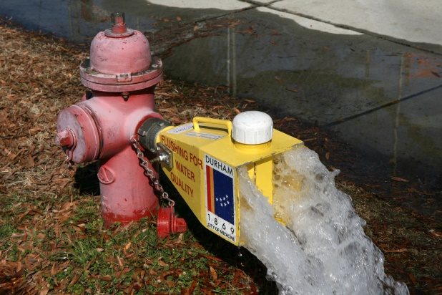
In 2011, TRUE Consulting was engaged to provide the Village with a formal unidirectional flushing (UDF) program for the annual flushing of watermains. The 2018 annual flushing program was completed in the spring and fall. The Village also maintains hydrants within the Village where the mains are also exposed to flushing activities.

Hydrants are inspected yearly to determine the unit’s ability to function properly, and to provide adequate fire protection. Village staff performs inspections such as checking the hydrant pressure, exposing any worn parts, and updating service records. In 2009, the Village began a program to include capital funding to allow for any required replacement of older fire hydrants.

    - Watermain Breaks
Unfortunately, municipalities will always have to deal with both unexpected watermain breaks and the disruption of those breaks to the domestic water system. However, most problems associated with breaks can be remedied in a short amount of time and thus, regular service can be quickly restored. The Village experienced no significant watermain breaks in 2018.

4.0 Water System Operator Training Program

The Village’s Water Distribution (WD) system is classed as a Level II water system through the Environmental Operators Certificate Program EOCP. This classification level is based on system complexities and the number of homes serviced. The Conditions of Permit to operate the water system are established and monitored by IHA and call for continual operator training and upgrading as well as the attainment of operator certification levels applicable to the level of classification of the municipal water system.

In 2018 the Village had one certified Level II WD full time water system operator and two Utility Operators containing Level I WD. Each of the water operators take new courses each year through the Village’s established Training Program in order to upgrade and/or keep current their operator certificates and knowledge to provide the Village with safe and efficient water system operations.

It is planned that the Village will see a second Level II WD operator through the efforts of our Training Program. Additionally, the Village is fortunate to live in close proximity and have positive working relationships with other local governments which allows for the sharing of knowledge and information between certified operators.

5.0 Water Quality Monitoring and Testing Program

The Drinking Water Protection Regulation sets minimal guidelines that water purveyors must meet in respect to water monitoring analysis. Therefore, the Village of Montrose is required to maintain the following components within its testing program:

- Monitor the drinking water source, the water in its system and the water it provides;
- Monitor the above not less than 4 times per month;
- Monitor for both Total Coliform bacteria and E. Coli;
- Have the analyses required for monitoring carried out by accredited laboratories that meet the requirements of the Drinking Water Protection Act and Public Health Officer; and
- Send monthly reports to the Public Health Inspector that summarize the above test results and daily water consumption totals.

In 2018, the regular sampling program of the Village provided samples from four locations per testing week as follows:

- 12th Avenue Sampling Station;
- Community Hall – 460 9th Ave;
- Well #1 – Wells Property, Highway 22A; and
- Well #3 – Wells Property, Highway 22A.

In addition to the sampling above, the Village also completes Comprehensive Drinking Water Analysis. This analysis provides information relating to inorganic parameters and total recoverable metals. The next comprehensive water analysis is scheduled to be completed in early 2019 and will be performed by CARO Analytical Services located in Kelowna, BC.

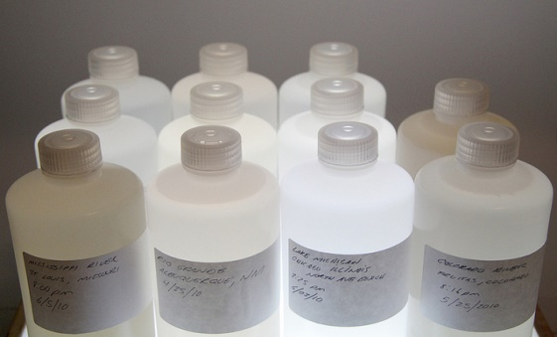
All water analysis on domestic water in the Village of Montrose is performed by CARO Analytical Services, located in Kelowna, BC, and Passmore Labs in Slocan Valley, BC. Both Passmore Labs and CARO Analytical Services employ methods, which are based on those foundations in “Standard Methods for the Examination of Water and Wastewater”, online Edition, published by the American Public Health Association, US EPA protocols found in “Test Methods for Evaluating Solid Waste, Physical/ Chemical Methods, SW846”, 3rd Edition and protocols published by the British Columbia Ministry of Environment.

5.1 Parameters
A maximum allowable concentration (MAC) has been established by Health Canada for microbiological criteria. Each MAC has been designed to safeguard human health and is based on projecting lifelong consumption of drinking water that contains the substances at the maximum concentration level. These MAC’s are identified in Schedule A of the Drinking Water Protection Regulation as follows:

Water Quality Standards for Potable Water

Parameter: |  | Standard:
Fecal coliform bacteria |  | No detectable fecal coliform bacteria per 100 ml
Escherichia coli |  | No detectable Escherichia coli per 100 ml
Total coliform bacteria
(a) 1 sample in a 30-day period |  | No detectable total coliform bacteria per 100 ml
(b) more than 1 sample in a 30-day period |  | At least 90% of samples have no detectable total coliform bacteria per 100 ml and no sample has more than 10 total coliform bacteria per 100 ml

5.2 Results
The Village’s monthly water sampling results are summarized in Appendix 2. Overall results indicate that the Village falls within the required Maximum Allowable Concentrations specified by Health Canada and the Drinking Water Protection

Regulations in respect to both Total Coliform and E. coli concentrations.
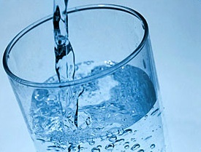
For comparison, in 2013, the Village fell outside of the required Maximum Allowable Concentrations allowed by Health Canada and the Drinking Water Protection Regulations in respect to Total Coliform concentrations in two of the twelve months.

Overall system sampling results indicate that in 2018, the Village fell well within the required Maximum Allowable Concentrations allowed by Health Canada and the Drinking Water Protection Regulations for the entire year in respect to E. coli concentrations.

Village of Montrose Water Sampling Results Summary for 2018

12th Avenue Sampling Station & Community Hall
The 12th Avenue Sampling Station and the Community Hall are two primary locations for water sampling of the distribution system within the Village. These samples are generally taken the first and third Tuesday of each month. In 2018, results from both Sampling Stations indicated no abnormal counts in respect to E. coli, Total Coliform or Background Colonies..

Well Pump Houses
The Well Pump Houses are also two primary locations for water sampling, and these samples are also generally taken the first and third Tuesday of each month. In 2018, results from the Well Pump Houses (Well #1 & #3) indicated no abnormal counts in respect to E. coli or Total Coliform.

6.0 Annual Consumption Records

Month
ML/day
ML/day
average
average
Jan
10.980
0.354
7.807
0.252
Feb
8.186
0.292
7.520
0.269
Mar
9.732
0.314
6.610
0.213
Apr
10.533
0.351
7.816
0.261
May
15.220
0.491
21.662
0.699
Jun
24.320
0.811
28.011
0.934
Jul
32.842
1.059
33.588
1.083
Aug
31.030
1.001
30.340
0.979
Sep
22.105
0.737
17.718
0.591
Oct
12.311
0.397
8.833
0.285
Nov
8.320
0.277
7.624
0.254
Dec
8.174
0.264
7.802
0.252
yearly total
193.753
185.331
monthly avg.
16.146
15.444
2015
2014
ML
ML

Table 1 – 2015 / 2016 / 2017/2018 Monthly Water Consumption Comparison

Month | 2015 |  |  |  |  |  | 2016 |  |  |  | 2017 |  |  |  | 2018
 | ML |  |  | ML/day |  |  | ML |  | ML/day |  | ML |  | ML/day |  | ML |  | ML/day
 |  |  |  | average |  |  |  |  | average |  |  |  | average |  |  |  | Average
Jan | 7.807 |  |  | 0.252 |  |  | 7.512 |  | 0.242 |  | 9.434 |  | 0.304 |  | 6.467 |  | 0.209
Feb | 7.520 |  |  | 0.269 |  |  | 6.562 |  | 0.234 |  | 7.833 |  | 0.279 |  | 7.496 |  | 0.268
Mar | 6.610 |  |  | 0.213 |  |  | 5.996 |  | 0.193 |  | 7.498 |  | 0.242 |  | 7.184 |  | 0.232
Apr | 7.816 |  |  | 0.261 |  |  | 11.485 |  | 0.383 |  | 7.576 |  | 0.253 |  | 8.545 |  | 0.285
May | 21.662 |  |  | 0.699 |  |  | 20.407 |  | 0.658 |  | 14.133 |  | 0.456 |  | 21.241 |  | 0.685
Jun | 28.011 |  |  | 0.934 |  |  | 22.181 |  | 0.739 |  | 25.096 |  | 0.836 |  | 24.566 |  | 0.819
Jul | 33.588 |  |  | 1.083 |  |  | 28.044 |  | 0.905 |  | 37.232 |  | 1.201 |  | 33.517 |  | 1.081
Aug | 30.340 |  |  | 0.979 |  |  | 31.364 |  | 1.012 |  | 36.294 |  | 1.171 |  | 34.173 |  | 1.102
Sep | 17.718 |  |  | 0.591 |  |  | 18.875 |  | 0.629 |  | 23.176 |  | 0.773 |  | 18.159 |  | 0.605
Oct | 8.833 |  |  | 0.285 |  |  | 7.572 |  | 0.244 |  | 9.414 |  | 0.304 |  | 8.302 |  | 0.268
Nov | 7.624 |  |  | 0.254 |  |  | 7.172 |  | 0.239 |  | 7.975 |  | 0.266 |  | 7.947 |  | 0.265
Dec | 7.802 |  |  | 0.252 |  |  | 8.375 |  | 0.270 |  | 9.422 |  | 0.304 |  | 9.377 |  | 0.302
Year total | 185.331 |  |  | 0.508 |  |  | 175.545 |  | 0.481 |  | 195.083 |  | 0.534 |  | 186.974 |  | 0.512
Month avg. | 15.444 |  |  |  |  |  | 14.629 |  |  |  | 16.257 |  |  |  | 15.581
In millions of litres

The Village of Montrose has been looking to achieve a reduction in the average consumption rate through participation in the Columbia Basin Trust Water Smart program and through enforcement of water usage bylaws, which were originally implemented in 2007 and have been consistently updated and/or refined over the past few years. In 2018, consumption levels decreased from 2017 to 2015 levels.

7.0 Water Conservation

In 2010, the Village of Montrose became a signatory to the Columbia Basin Water Smart Initiative which has assisted local governments across the region to reduce their local water consumption. The two main ways to achieve this reduction is through

- reducing the amount of water used on lawns and gardens (Outdoor Irrigation); and
- reducing the amount of water that leaks out of drinking water systems.

A Village of Montrose Water Smart Action Plan was completed in 2010 as part of this initiative which identified that the most significant use of water in Montrose appears to be for domestic irrigation. Leakage within the Village’s water system is considered negligible because the estimated rate of indoor domestic use is approximately equivalent to the average winter day demand.
Since 2011, the Village has participated in the CBT Water Smart Program. 2011-2013, the Village partnered with neighbouring local governments in the CBT Water Smart Ambassador Program. The ambassadors’ goal was to reduce outdoor water use in the summer and her duties included public education, municipal park water use audits and free lawn and garden water assessments, which helped residents understand the amount of water their properties need, and how much water is really required. She also educated residents about watering restrictions.
The program was more successful in 2012 and saw a reduction in assessments is 2013. The Ambassador program is a recommended program in the Water Smart Action Plan. The CBT continues to assess the program and it is expected that further improvements will provide a greater utilization of the program by Montrose residents which will reduce water consumption.

Other Water Smart initiatives over the years included water loss management training, completion of ICI metering in the Village and meter pit installation to the Village’s WWTP, and completion of Water Service Rates Analysis and Future Revenue Requirements Studies.

The Village’s 2010 Water Smart Action Plan that was completed jointly with the Columbia Basin Trust, was updated for the Village in October of 2016 and adopted by Village Council. This document provides the Village with direction and guidance on the Village’s water usage plans for the period of 2016 - 2020. The Village will be completing an update to the Village’s Water Plan in 2020 for the period of 2021-2025.

8.0 Water Issues in 2018

The Village was required to connect to the neighboring Beaver Falls water system for approximately three months in 2018. A total of six residents were included in that connection. This connection was part of the Upper Water Reservoir upgrade project that was completed at that time. No significant issues were experienced apart from some initial water pressure adjustment problems experienced by a few of the six residents who were connected to a special pumping pressure system during that time.

Minor Source and Distribution System Interruptions
General source, pumping and distribution system interruptions occur on an irregular basis due to many factors, including, but not limited to the following:

- Power Supply Outage,
- Power Supply Interruptions or Spikes,
- Controls Communications Loss and/or Failure,
- Water Main Leaks and Repairs, and
- Service Connections Repairs.

No minor source disruptions occurred in 2018.

9.0 2018 Capital Works and Proposed 2019 Capital Works

The Village has maintained a philosophy of approaching infrastructure related problems in a proactive manner. This is evident by the numerous studies undertaken in regard to the water distribution piping network and an assortment of issues related to water consumption.

2018 Capital Works Projects

Upper Reservoir Roof Upgrades
This project aims to reinforce the upper reservoir roof structure through the addition of roof angles to the existing roof support ribs. This project was identified in the 2010 Water Master Plan. The project is forecast to extend the useful life of the 37-year-old reservoir to about 2050. The project was tendered in late 2017 with the goal of being completed in 2018. The project involved the addition of fabricated steel beams to support the roofing structure of the reservoir, and the reapplication of a corrosion resistant epoxy coating to the interior of the tank where needed. The Village supplemented its water source with the current tie-in from the Beaver Falls Waterworks District, for the duration of the project, as the upper reservoir was taken out of service for 10 weeks.

Valve Replacement Programs
Several valves were replaced under this program. All other components were deemed to be in sound condition.

Well Site - Valve upgrades
The wells were inspected and cleaned by . This is part of regular well maintenance that the Village completes every few years.

Water Distribution Pipe Assessment
The Village continued to monitor pipe conditions and continued to look for funding opportunities to help with costs of future major water line upgrades.

Cross Connection Control Plan Implementation

As per IHA Permit, the Village is required to have a Cross Connection Control Program to identify, eliminate and prevent cross connections with non-potable water sources for the Village of Montrose. Initial contact was made with a consultant to assist the Village in the development of the plan with some of its implementation in 2015 and further implementation in 2016.

Projected 2019 Capital Works

Fire Hydrant and Valve Replacement Programs
This program will continue in 2019 and will plan to incorporate the continued inspection of the fire hydrants and valves.

800 Block – 9th Ave Watermain Replacement
This project is part of the road/underground works replacement program. The plan includes the replacement of the watermain and the associated The Village will be supplementing its water source with the current tie-in from the Beaver Falls Waterworks District, for the duration of the project, as the upper reservoir will be taken out of service for up to 11 weeks.

Annual review and completion of the work program improves the water service to residents in the Village and will result in a reduction to disruptions during future waterworks projects.

10.0 Emergency Response and Contingency Plan

The Village currently has in place policies that deal with water quality notification (Policy # 5600) and emergency call outs (Policy # 7130). Both policies may be found in Appendix 4. The water quality notification Policy #5600 was revised in early 2009 as per the requirements of the Public Health Inspector, IHA.

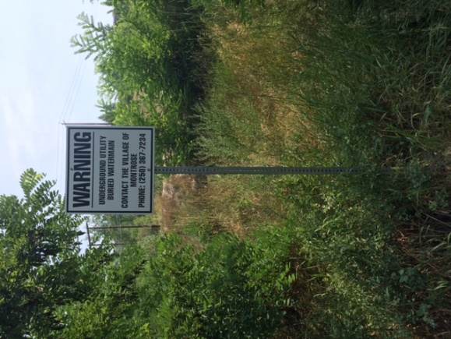 | When a major emergency occurs with respect to water supply, the Village of Montrose and the Beaver Falls Waterworks District have an agreement in place that allows either water system to act as a back-up system for the other. The process of backing up either system includes the fact that qualified representatives from each water system are present and work together to open the necessary valves for the systems to be properly combined. Further, the Village and Beaver Falls representatives convene regularly to discuss any upgrades to each respective distribution system and provide updates on a variety of other water purveyor matters common to both systems.
Formal Response Plans for specific emergency events are being developed and will be completed in 2019.

11.0 Conclusion

Since the implementation of the Drinking Water Protection Act and Drinking Water Protection Regulations, standards with respect to on-going operator training, water sampling, system monitoring, emergency response plans, long-range planning and public reporting have increased dramatically.

The Village of Montrose looks forward to the continuous implementation of this new legislation and welcomes the opportunity to inform residents of the Village’s practices relating to the supply and distribution of domestic potable water. Further, as a result of presenting this annual report, the Village hopes that residents understand the current complexities municipalities face in supplying an adequate water source to its residents and encourages residents to help the Village maintain a safe, reliable water source for both current and future generations.

APPENDIX 2

Village of Montrose
2018 Water Quality Testing Records
All testing carried out by CARO Environmental Services of Kelowna (250)765-9646
Tested for Total Coliforms & E. Coli

JANUARY 2018
Date | Location | Total Coliform | E. Coli
08-Jan | 12th Ave Sample Station | <1 | <1
08-Jan | Community Hall - 490 9th Ave | <1 | <1
08-Jan | Well Pump #1 - Hwy 22A | <1 | <1
08-Jan | Well Pump #2 - Hwy 22A | <1 | <1
18-Jan | 12th Ave Sample Station | <1 | <1
18-Jan | Community Hall - 490 9th Ave | <1 | <1
18-Jan | Well Pump #1 - Hwy 22A | <1 | <1
18-Jan | Well Pump #2 - Hwy 22A | <1 | <1

FEBRUARY 2018
Date | Location | Total Coliform | E. Coli
08-Feb | 12th Ave Sample Station | <1 | <1
08-Feb | Community Hall - 490 9th Ave | <1 | <1
08-Feb | Well Pump #1 - Hwy 22A | <1 | <1
08-Feb | Well Pump #2 - Hwy 22A | <1 | <1
22-Feb | 12th Ave Sample Station | <1 | <1
22-Feb | Community Hall - 490 9th Ave | <1 | <1
22-Feb | Well Pump #1 - Hwy 22A | <1 | <1
22-Feb | Well Pump #2 - Hwy 22A | <1 | <1

MARCH 2018
Date | Location |  | Total Coliform |  | E. Coli
08-Mar | 12th Ave Sample Station |  | <1 |  | <1
08-Mar | Community Hall - 490 9th Ave |  | <1 |  | <1
08-Mar | Well Pump #1 - Hwy 22A |  | <1 |  | <1
08-Mar | Well Pump #2 - Hwy 22A |  | <1 |  | <1
APRIL 2018
Date | Location | Total Coliform | E. Coli
05-Apr | 12th Ave Sample Station | <1 | <1
05-Apr | Community Hall - 490 9th Ave | <1 | <1
05-Apr | Well Pump #1 - Hwy 22A | <1 | <1
05-Apr | Well Pump #2 - Hwy 22A | <1 | <1
19-Apr | 12th Ave Sample Station | <1 | <1
19-Apr | Community Hall – 490 9th Ave | <1 | <1
19-Apr | Well Pump #1 – Hwy 22A | <1 | <1
19-Apr | Well Pump #2 – Hwy 22A | <1 | <1

MAY 2018
Date | Location | Total Coliform | E. Coli
03-May | 12th Ave Sample Station | <1 | <1
03-May | Community Hall - 490 9th Ave | <1 | <1
03-May | Well Pump #1 - Hwy 22A | <1 | <1
03-May | Well Pump #3 - Hwy 22A | <1 | <1
17-May | 12th Ave Sample Station | <1 | <1
17-May | Community Hall - 490 9th Ave | <1 | <1
17-May | Well Pump #1 - Hwy 22A | <1 | <1
17-May | Well Pump #3 - Hwy 22A | <1 | <1

JUNE 2018
Date | Location | Total Coliform | E. Coli
06-June | 12th Ave Sample Station | <1 | <1
06-June | Community Hall - 490 9th Ave | <1 | <1
06-June | Well Pump #1 - Hwy 22A | <1 | <1
06-June | Well Pump #3 - Hwy 22A | <1 | <1
27-June | 12th Ave Sample Station | <1 | <1
27-June | Community Hall - 490 9th Ave | <1 | <1
27-June | Well Pump #1 - Hwy 22A | <1 | <1
27-June | Well Pump #3 - Hwy 22A | <1 | <1

JULY 2018
Date | Location | Total Coliform | E. Coli
04-Jul | 12th Ave Sample Station | <1 | <1
04-Jul | Community Hall - 490 9th Ave | <1 | <1
04-Jul | Well Pump #1 - Hwy 22A | <1 | <1
04-Jul | Well Pump #3 - Hwy 22A | <1 | <1
18-Jul | 12th Ave Sample Station | <1 | <1
18-Jul | Community Hall - 490 9th Ave | <1 | <1
18-Jul | Well Pump #1 - Hwy 22A | <1 | <1
18-Jul | Well Pump #3 - Hwy 22A | <1 | <1

AUGUST 2018
Date | Location | Total Coliform | E. Coli
08-Aug | 12th Ave Sample Station | <1 | <1
08-Aug | Community Hall - 490 9th Ave | <1 | <1
08-Aug | Well Pump #1 - Hwy 22A | <1 | <1
08-Aug | Well Pump #2 - Hwy 22A | <1 | <1
22-Aug | 12th Ave Sample Station | <1 | <1
22-Aug | Community Hall - 490 9th Ave | <1 | <1
22-Aug | Well Pump #1 - Hwy 22A | <1 | <1
22-Aug | Well Pump #2 - Hwy 22A | <1 | <1

SEPTEMBER 2018
Date | Location | Total Coliform | E. Coli
05-Sep | 12th Ave Sample Station | <1 | <1
05-Sep | Community Hall - 490 9th Ave | <1 | <1
05-Sep | Well Pump #1 - Hwy 22A | <1 | <1
05-Sep | Well Pump #2 - Hwy 22A | <1 | <1
19-Sep | 12th Ave Sample Station | <1 | <1
19-Sep | Community Hall - 490 9th Ave | <1 | <1
19-Sep | Well Pump #1 - Hwy 22A | <1 | <1
19-Sep | Well Pump #2 - Hwy 22A | <1 | <1

OCTOBER 2018
Date | Location | Total Coliform | E. Coli
03-Oct | 12th Ave Sample Station | <1 | <1
03-Oct | Community Hall - 490 9th Ave | <1 | <1
03-Oct | Well Pump #1 - Hwy 22A | <1 | <1
03-Oct | Well Pump #2 - Hwy 22A | <1 | <1
17-Oct | 12th Ave Sample Station | <1 | <1
17-Oct | Community Hall - 490 9th Ave | <1 | <1
17-Oct | Well Pump #1 - Hwy 22A | <1 | <1
17-Oct | Well Pump#2 - Hwy 22A | <1 | <1

NOVEMBER 2018
Date | Location | Total Coliform | E. Coli
07-Nov | 12th Ave Sample Station | <1 | <1
07-Nov | Community Hall - 490 9th Ave | <1 | <1
07-Nov | Well Pump #1 - Hwy 22A | <1 | <1
07-Nov | Well Pump #2 - Hwy 22A | <1 | <1
21-Nov | 12th Ave Sample Station | <1 | <1
21-Nov | Community Hall - 490 9th Ave | <1 | <1
21-Nov | Well Pump #1 - Hwy 22A | <1 | <1
21-Nov | Well Pump#2 - Hwy 22A | <1 | <1

DECEMBER 2018
Date | Location | Total Coliform | E. Coli
05-Dec | 12th Ave Sample Station | <1 | <1
05-Dec | Community Hall - 490 9th Ave | <1 | <1
05-Dec | Well Pump #1 - Hwy 22A | <1 | <1
05-Dec | Well Pump #2 - Hwy 22A | <1 | <1

APPENDIX 3

Village of Montrose
2018 Chlorine Residual Monitoring Summary

 | January |  |  | February |  |  | March |  |  | April
 | WTP | Dist. |  | WTP | Dist. |  | WTP | Dist. |  | WTP | Dist.
Total Samples | 11 | 23 |  | 7 | 22 |  | 11 | 18 |  | 11 | 13
Month High (ppm) | 0.49 | 0.46 |  | 0.54 | 0.49 |  | 0.54 | 0.52 |  | 0.45 | 0.47
Month Low (ppm) | 0.37 | 0.29 |  | 0.37 | 0.26 |  | 0.37 | 0.29 |  | 0.36 | 0.32
Month Average (ppm) | 0.44 | 0.39 |  | 0.45 | 0.36 |  | 0.44 | 0.40 |  | 0.41 | 0.40
 | May |  |  | June |  |  | July |  |  | August
 | WTP | Dist. |  | WTP | Dist. |  | WTP | Dist. |  | WTP | Dist.
Total Samples | 4 | 19 |  | 13 | 24 |  | 12 | 17 |  | 12 | 19
Month High (ppm) | 0.46 | 0.60 |  | 0.47 | 0.57 |  | 0.47 | 0.51 |  | 0.41 | 0.44
Month Low (ppm) | 0..40 | 0.30 |  | 0.24 | 0.21 |  | 0.36 | 0.23 |  | 0.33 | 0.22
Month Average (ppm) | 0.44 | 0.47 |  | 0.38 | 0.32 |  | 0.41 | 0.36 |  | 0.34 | 0.32
 | Sept |  |  | Oct |  |  | November |  |  | December
 | WTP | Dist. |  | WTP | Dist. |  | WTP | Dist. |  | WTP | Dist.
Total Samples | 10 | 20 |  | 12 | 23 |  | 12 | 19 |  | 11 | 21
Month High (ppm) | 0.45 | 0.46 |  | 0.57 | 0.56 |  | 0.54 | 0.52 |  | 0.59 | 0.57
Month Low (ppm) | 0.36 | 0.21 |  | 0.33 | 0.21 |  | 0.26 | 0.15 |  | 0.48 | 0.24
Month Average (ppm) | 0.40 | 0.31 |  | 0.49 | 0.37 |  | 0.49 | 0.32 |  | 0.51 | 0.40
WTP = Water Treatment Plant - Analyzer Data
Dist. = Distribution System - samples taken from various locations within Village
All measurements represent free Cl2 (mg/L)

